**Highland Academy**

**Academic Policy Committee**

DECEMBER 7, 2023 Minutes

5:30-7:00

**Zoom Information:**

<https://asdk12.zoom.us/j/2314599803?pwd=eGNTbVE5eU9mV251a3NHeUdDVVRrQT09>

Meeting ID: 231 459 9803

Passcode: phoenix

| **Cyclical Resources:** | **Resources for this meeting:** |
| --- | --- |
| [HACS APC Running Agenda Items Calendar](https://docs.google.com/document/d/1_Ye7-BOqfsiGPZvm3PE86QT969qwc6iOvctsG59liTY/edit#heading=h.ln7kmthxyxcp)  [Highland Collaborative Leadership Compact](https://docs.google.com/document/d/1VPn_wd-cktlWRWREhlvgxSyT13ZhsPtjSRQrGnSPFsw/edit#heading=h.centuepgsh7b)   * [APC Calendar](https://docs.google.com/spreadsheets/d/1G6TKFqSs3NkJlgwUvpCisl70aCj3nKCaZTZHH095sQ4/edit#gid=422462332) * [APC Main Folder](https://drive.google.com/drive/folders/1NGJfz4Rk_l2CuOlhqX1WP3nArMb9I0y1?usp=sharing) * [SY2024 Goals All in One](https://docs.google.com/document/d/1yQ60N9gqwHLMPzpI-bIu0pxUhMnIfsH68cAAv0eRFwM/edit?usp=sharing) * [Current Board Roster](https://docs.google.com/document/d/1UEp0Z6qIebBQ9x8XblanTmo70WTvHBb57etXfu1C6wg/edit) * [By-Laws](https://docs.google.com/document/d/1eJ4Z9PIikI-wuZNOHdPovum2XCzE1QW8/edit) | * [November 2023 APC Minutes](https://docs.google.com/document/d/1l5L2CZWRpRMfY2hAUmfK0iEoThTS02f_SWF7ncaLfgs/edit) * [Additional Budget Information](https://docs.google.com/presentation/d/1g4837quxnSJm2DyhKHl-oFs24tI99wAFXk8K46scp88/edit?usp=sharing) * [Performance Committee Action Plan](https://docs.google.com/document/d/1an7jlZWExYDH0hbzg7qgl_A5dtJjW9tbuu6JVpXEVj4/edit) |

**Agenda**

1.Determination of Quorum and Call to Order *@ 5:40pm Laura Hilger, Meghan Cunningham, Joe Winter, Philippe Janicka, Nicole Crosby, Jill Harter*

2.Land Acknowledgement:

**Please join me by acknowledging that we all live and work on the land of the Dena’ina people:**

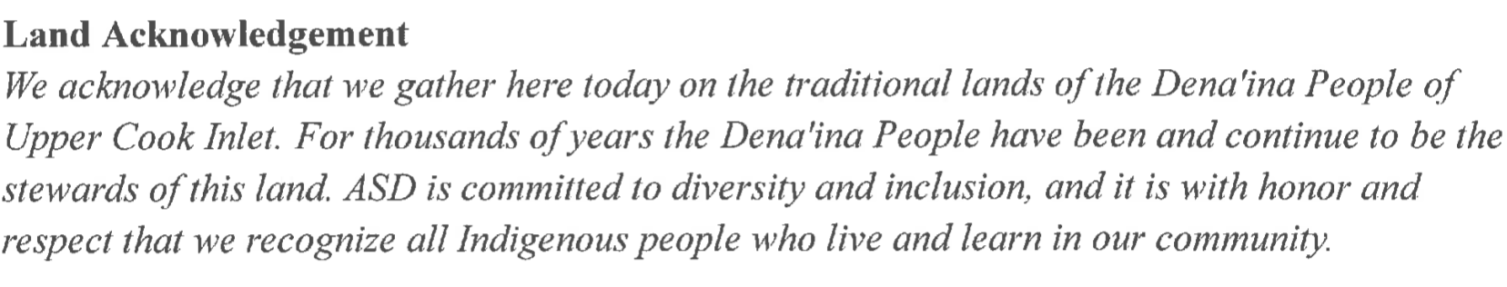

3. Clarifications on Agenda and Set Intentions

4. Approval of the NOVEMBER minutes *Philippe moved to approve, Meghan seconded, motion carried unanimously*

5. Public comment

6. Principal Report

* **ACTION:**
  + OASIS count for 2024/2025
  + Budget

*Philippe moved for a 195 projected enrollment and addition of a full time paraprofessional, Laura seconded, motioned failed*

*Meghan moved 200 projected enrolment and additional of a full time paraprofessional and a 0.4 counselor, Joe seconded, motion carried unanimously*

* **NON-ACTION:**
  + Celebrations
  + Data Presentation

7. Meeting the mission of the Charter

* **PTSO Liaison Report Out**
* **New board member Election**

*Joe moved to accept Jill Harter as new APC board member, Philippe seconded, motion carried unanimously*

* **Continue Board Officer Elections for SY2024**
  + Treasurer

*Joe moved to accept Jill Harter as treasurer, Philippe seconded, motion carried unanimously*

* **Committee Updates**
  + Committee Feedback
  + Goal Committee Workshop
    - Schedule next committee meetings via our new APC Calendar

8. *Adjournment @7:05 pm*

**Next Board Meeting:** January 18, 2024 5:30- 7:00pm

Have any agenda items? Add to our [Running Agenda Items Calendar](https://docs.google.com/document/d/1_Ye7-BOqfsiGPZvm3PE86QT969qwc6iOvctsG59liTY/edit?usp=sharing)

**Notes from Academy:**

**Board Academy Overview: What do we need to start, stop, and/or continue?**

* + START: Via zoom, we must do votes by roll call
  + START: new motion process
    - Members make a motion as opposed to chair calling for one
    - Motion needs a 2nd
    - Open Discussion
    - Then Vote
  + STOP: Don’t need a vote to approve agenda or to end meeting
  + CONTINUE: By-Law Review, Committees, and board evaluations

*The APC reserves the right to enter into executive session as provided for in State Law on any agenda item. Executive sessions may be entered into for the following subjects as permitted by law: (1) matters the immediate knowledge of which would clearly have an adverse effect upon the finances of the District; (2) subjects that tend to prejudice the reputation and character of any person, provided that the person may request a public discussion; (3) matters which by law, municipal charter, or ordinance are required to be confidential; and, (4) matters involving consideration of government records that by law are not subject to public disclosure. Motions to go into executive session should specify the subject of the proposed executive session without defeating the purpose of addressing the subject in private.*